Merit Increase Mail Merge: Step-by-Step Guide

Step 1: SIR spreadsheet prep

For the mail merge to work, you will need to prepare the SIR spreadsheet. Please follow these directions exactly, or your Mail Merge will not work. This is particularly important when naming the columns because the Merit Letter template is programed to look for specific column headings.
- Review SIR spreadsheet to ensure that all rows and columns are accurate. Please double check names match employee IDs, etc.
- Separate first name and last name
  - Insert column to the right of the name. Label that “First Name”. Do not change the name of any other columns.
  - Select the column with employee name
  - Go to Data>Text to Columns
  - Select delimited option:
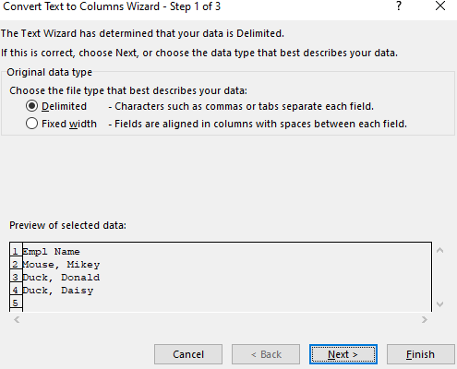

  - Uncheck separate by tab and select separate by comma
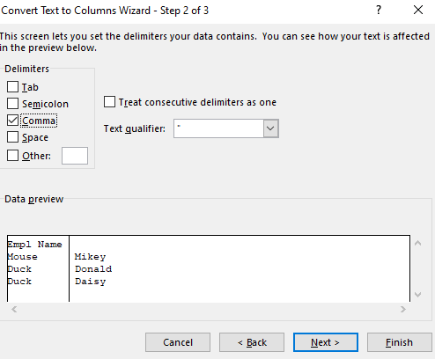

  - Select finish and okay. This will move the employee’s first name into a new column.
  - If you want to have the letters include a prefix (Dr., Mr. Mrs.) you will need to add an additional column and enter that information into the spreadsheet. You can also do this manually on the actual letter. However, since that information was not included in the SIR spreadsheet, it needs to be entered in. If you want the letter to read “Dear Dr. Smith” you will need to add the prefixes either to the spreadsheet and add the merge fields onto the template letter or manually type “Dr. Smith” on each individual letter.
  - Save this spreadsheet (either as the SIR or a separate document but remember the name of the document and where you saved it).

Step 2: Mail Merge

- Open the “University Staff Merit Increase Template 11 2022” Word document. Select “No” when you get the question so that you can input your own data source.
- If you have permission, insert the electronic signature of the letter signer into the document.
- If the department uses the past three years of performance evaluations (faculty only) to determine the employee’s merit increase, please change that on the template for those employees.
- The Job Code Description and Position number are optional. They may be helpful for employees that have several positions and will be receiving multiple merit increase letters. If you do not think these will be helpful, or will cause confusion, you can delete them from the word document. Employee ID numbers are required on the letters.
- Go to Mailings>Start Mail Merge> Letters:
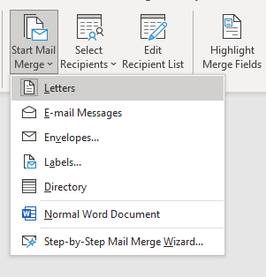
- Select Recipients Using Existing List and select the SIR spreadsheet you edited from Step 1:
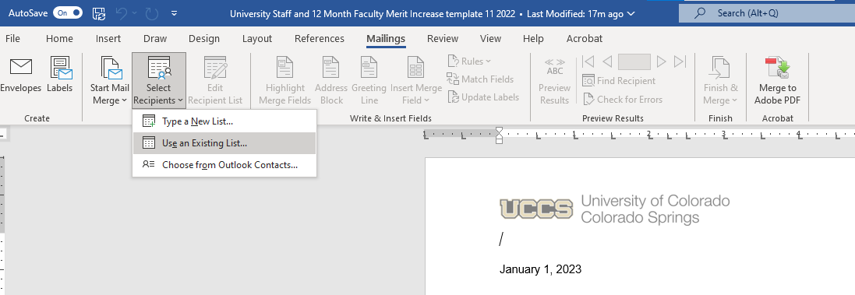

- Find the spreadsheet you would like to use

- Select your table with the correct tab:
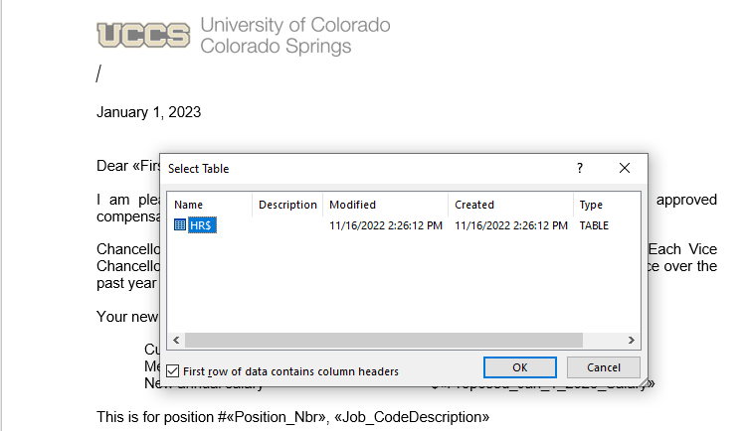

- Go to Edit Recipient List and select your recipients. You may have some blank lines in in the SIR and you can unselect those boxes, so it doesn’t create blank letters.
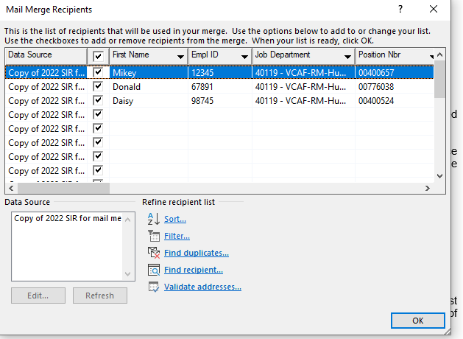

- You will see all the documents listed. You can preview results and scroll through them:
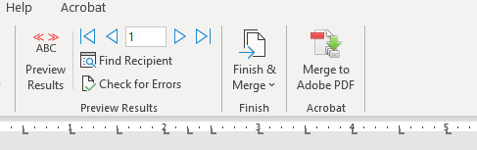

- Select Finish & Merge> Edit Individual Documents to create the document. 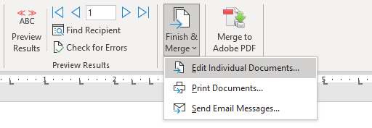

- Edit individual documents as needed to account for individual situations, such as promotions, multiple speed types or positions, or any other adjustments that are being made as of January 1, 2023.
- Check to ensure that the letters match the information for each employee on the SIR spreadsheet. This includes position numbers, employee ID numbers, salary amounts and merit increase amounts.

Step 3: Saving and Sending the Letters

- Select Print Documents from the Finish & Merge so that you can save to a PDF.
- Save the document as one large PDF so that you can submit it in a Cherwell Ticket. Human Resources will use this large file to automatically put the letter into the employee’s OnBase file. Do not send pictures or screen shots of the letters; we cannot accept these file types.
- Exit the Template – If you choose to save it – Select a different file name than the finished, merged document.
- Submit the merit increase letters (as one large file) in Cherwell for filing into the employee’s file: https://cherwell3.uccs.edu/CherwellPortal/hr?_=66e92f41#0 using the Pay Rate Change link. Sending via e-mail to HRhelp may not be possible due to the file size of the attachment.
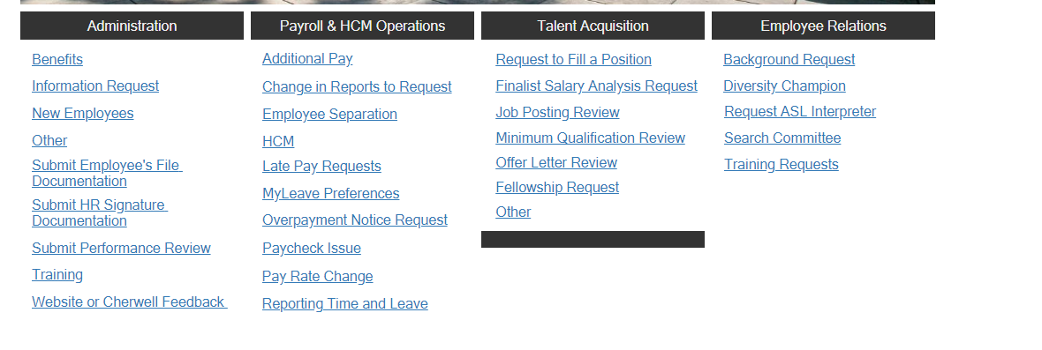
- Save individual letters by printing to PDF, one page at a time, so you can send the letters to the employees via Outlook.

