Merit Increase Letter Step-by-Step without mail merge

- Use templates provided by central Human Resources to hand enter information into the merit increase letter. This will include typing in salary information, position numbers and employee ID numbers and must be accurate. Due to the large opportunity for error, this is not the recommended procedure.
- If you have permission, insert the electronic signature of the letter signer into the document.
- If the department uses the past three years of performance evaluations (faculty only) to determine the employee’s merit increase, please change that on the template for those employees.
- The Job Code Description and Position number are optional. They may be helpful for employees that have several positions and will be receiving multiple merit increase letters. If you do not think these will be helpful, or will cause confusion, you can delete them from the word document. Employee ID numbers are required on the letters.
- Copy and paste the template wording into as many pages you will need for the number of letters you are creating. Create only ONE master document to begin.
- Edit individual letters as needed to account for individual situations, such as promotions or any other adjustments that are being made as of January 1, 2023.
- Check to ensure that the letters match the information for each employee on the SIR spreadsheet. This includes position numbers, employee ID numbers, salary amounts and merit increase amounts.
- Save the document as one large PDF so that you can submit it in a Cherwell Ticket. Human Resources will use this large file to automatically put the letter into the employee’s OnBase file. Do not send pictures or screen shots of the letters; we cannot accept these file types.
- Submit the merit increase letters (as one large file) in Cherwell for filing into the employee’s file: https://cherwell3.uccs.edu/CherwellPortal/hr?_=66e92f41#0 using the Pay Rate Change link. Sending via e-mail to HRhelp may not be possible due to the file size of the attachment.

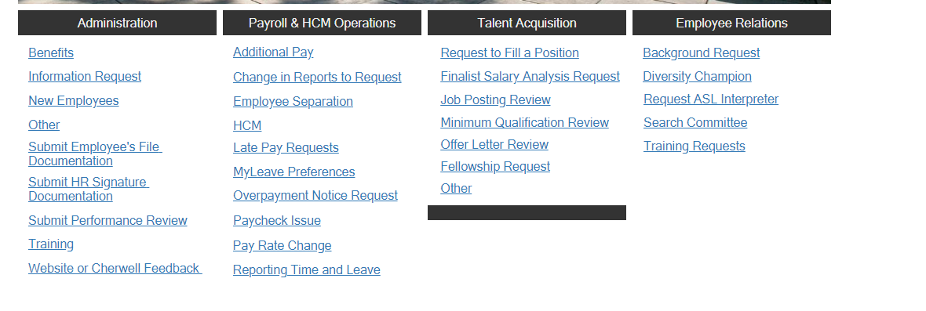
- Save individual letters by printing to PDF, one page at a time, so you can send the letters to the employees via Outlook.

