PAYROLL CALENDAR – UCCS April | 2023
Monday | Tuesday | Wednesday | Thursday |  | Friday | Sat/Sun
1/2 PPE 04/01/23
Pay Run ID BW040123
Earn dates 03/19-04/01/23
3 | 4 Time for Bi-Weekly 04/01/23 End Date must be approved & Posted in HCM by 5:00 PM  OC033023 uploads due 5 pm | 5 Letters/Entries/Additional pay due in HR/HCM for approval for April Monthly Pay  Processing OC033023 |  | 6  BW uploads due 5pm | 7  Processing BW040123  OC033023 PAYDAY | 8/9
10 W-4 and Direct Deposits should be entered no later than 5pm for April Monthly Payroll  Run Payroll Register  BW040121 | 11  OC040623 uploads due 5 pm | 12  PULL DEADLINE 10 AM:  BW PPE 040123  Processing OC040623 |  | 13 | 14 Timesheets/Leave for March 2023 must be approved & posted in HCM by 5pm  BW040123 PAYDAY  (Pay Run ID BW040123)  OC040623 PAYDAY | 15/16  PPE 04/15/23  Pay Run ID BW041523  Earn dates 04/02-04/15/23  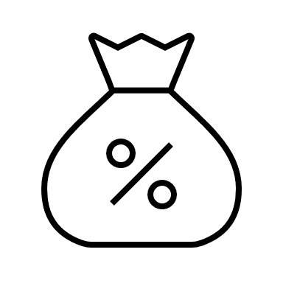
17 | 18 Time for Bi-Weekly 04/15/23 End Date must be approved & Posted in HCM by 5:00 PM  MON uploads due 5 pm  Pay Run ID MN043023  Processing MN PPE 04/30/23  NO OFF-CYCLE THIS WEEK  * | 19  Processing MN043023  NO OFF-CYCLE THIS WEEK  * |  | 20  Processing MN043023  BW uploads due 5pm  * | 21  Run Payroll Register  MON PPE 04/30/23  Processing BW041523  NO OFF-CYCLE THIS WEEK  * | 22/23
24  Run Payroll Register  BW041521 | 25  OC042023 uploads due 5 pm | 26  PULL DEADLINE 10 AM:  MON PPE 043023  PULL DEADLINE 10 AM:  BW PPE 041523  Processing OC042023 |  | 27 | 28  MON PPE 04/30/23 PAYDAY  Pay run ID MN043023  BW041523 PAYDAY  (Pay Run ID BW041523)  OC042023 PAYDAY | 29/30  PPE 04/29/23  Pay Run ID BW042923  Earn dates 04/16-04/29/23
* No off-cycle payroll

