2023 Juneteenth- Personal Observance Day

Guidance for Employees and HR Liaisons

Usage:
Current: Personal Observance Day for 2023 must be used by June 30, 2023.

Future: A Personal Observance Day for Juneteenth is under discussion for 2024 and future years; further information will be communicated at a later date.

Eligibility:

Employees who are eligible for paid holidays are eligible for the Personal Observance Day (prorated per percentage of appointment).
Employees leaving the university before June 30, 2023, may use the Personal Observance
Day before they depart. The Personal Observance Day is not eligible to be paid out upon separation.

Timekeeping:

Employees will request the Personal Observance Day in advance in MyLeave using the code “Personal Observance Day”. Enter “2023 Juneteenth Holiday” in the description when requesting time off.

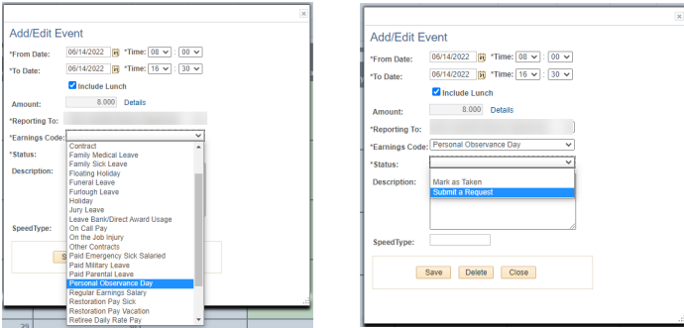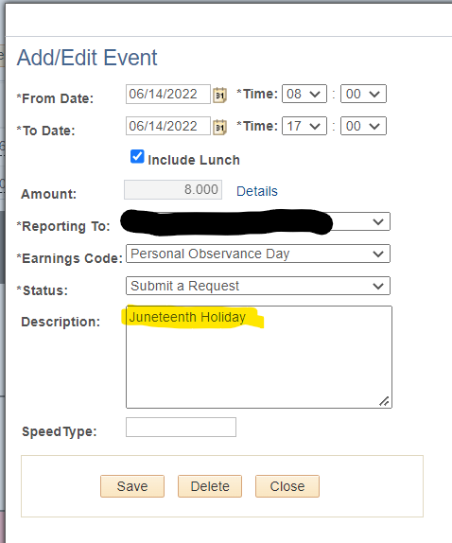

Tracking:
A query report has been developed to help monitor the usage of this leave category.
- Log into the employee portal.
- Open the CU Resources dropdown menu and click Business Tools.
- Select the HCM tile and choose HCM Community Users from the drop-down menu.
- Click the HCM WorkCenter tile.
- Select the Resources tab, select Query Manager and search for CUES_HCM_POD_LEAVE.

Additional Information:
https://www.cu.edu/blog/hcm-community/processing-new-personal-observance-day-leave-category

For Monthly/Hourly employees:
The department HRL will enter matching hours for the Person Observance Day as REG (required) in CU Time. This is the same process followed with any exception code (such as sick or vacation), with the only difference being that while most earnings codes do move from My Leave to CU Time, Personal Observance Day and regular holidays will not.

