PAYROLL CALENDAR – UCCS November | 2023
Monday | Tuesday | Wednesday | Thursday | Friday | Sat/Sun
30 | 31 Time for Bi-Weekly 10/28/23 End Date must be approved & Posted in HCM by 5:00 PM  MN103123 PAYDAY  Pay Run ID MN103123  OC102623 uploads due 5 pm | 1  Processing OC102623 | 2  BW uploads due 5pm | 3  Processing BW102823  OC102623 PAYDAY | 4/5
6 Letters/Entries/Additional pay due in HR/HCM for approval for November Monthly Pay  Run Payroll Register  BW102823 | 7  PULL DEADLINE 10 AM:  BW PPE 102823  OC110223 uploads due 5 pm | 8  Processing OC110223 | 9  BW102823 PAYDAY  (Pay Run ID BW102823  OC110223 PAYDAY | 10 W-4 and Direct Deposits should be entered no later than 5pm for November Monthly Payroll | 11/12  PPE 11/11/23  Pay Run ID BW111123  Earn dates 10/29-11/11/23
13 | 14 Time for Bi-Weekly 11/11/23 End Date must be approved & Posted in HCM by 5:00 PM  OC110923 uploads due 5 pm | 15 Timesheets/Leave for October 2023 must be approved & posted in HCM by 5pm  Processing OC110923 | 16  BW uploads due 5pm | 17  MON uploads due 5 pm  Pay Run ID MN113023  Processing MN PPE 11/30/23  Processing BW111123  OC110923 PAYDAY | 18/19
20  Processing MN113023  Run Payroll Register  BW111123 | 21  Processing MN113022  NO OFF-CYCLE THIS WEEK  * | 22 UCCS Chancellor’s Admin Day Off  Run Payroll Register  MON PPE 11/30/23  PULL DEADLINE 10 AM:  BW PPE 111123  NO OFF-CYCLE THIS WEEK  * | 23 Thanksgiving Day  ALL CAMPUSES CLOSED  (Bank holiday)  NO OFF-CYCLE THIS WEEK  *  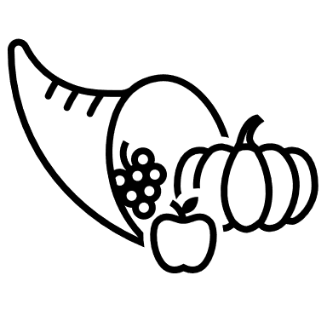 | 24 Day after Thanksgiving  UCB, UCCS, Anschutz, and SYS CLOSED  (Not a bank holiday)  BW111123 PAYDAY  (Pay Run ID BW111123  NO OFF-CYCLE THIS WEEK  * | 25/26  PPE 11/25/23  Pay Run ID BW112523  Earn dates 11/12-11/25/23
27 | 28 Time for Bi-Weekly 11/25/23 End Date must be approved & Posted in HCM by 5:00 PM  PULL DEADLINE 10 AM:  MON PPE 113023  OC112323 uploads due 5 pm | 29  Processing OC112323 | 30  MN113023 PAYDAY  Pay Run ID MN113023  BW uploads due 5pm
* No off-cycle payroll

