PAYROLL CALENDAR – UCCS March | 2024
Monday | Tuesday | Wednesday | Thursday | Friday | Sat/Sun
 |  |  |  | 1  BW021724 PAYDAY  (Pay Run ID BW021724)  OC022224 PAYDAY | 2/3  PPE 03/02/24  Pay Run ID BW030224  Earn dates 02/18-03/02/24
4 | 5 Time for Bi-Weekly 03/02/24 End Date must be approved & Posted in HCM by 5:00 PM  OC022924 uploads due 5 pm | 6 Letters/Entries/Additional pay due in HR/HCM for approval for March Monthly Pay  Processing OC022924 | 7  BW uploads due 5 pm | 8 W-4 and Direct Deposits should be entered no later than 5pm for March Monthly Payroll  Processing BW030224  OC022924 PAYDAY | 9/10
11  Run Payroll Register  BW030224 | 12  OC030724 uploads due 5 pm | 13  PULL DEADLINE 10 AM:  BW PPE 030224  Processing OC030724 | 14 | 15 Timesheets/Leave for February 2024 must be approved & posted in HCM by 5pm  BW030224 PAYDAY  (Pay Run ID BW030224)  OC030724 PAYDAY | 16/17  PPE 03/16/24  Pay Run ID BW031624  Earn dates 03/03-03/16/24
18 | 19 Time for Bi-Weekly 03/16/24 End Date must be approved & Posted in HCM by 5:00 PM  MON uploads due 5 pm  Pay Run ID MN033124  Processing MN PPE 03/31/24  NO OFF-CYCLE THIS WEEK  * | 20 Processing MN033124  NO OFF-CYCLE THIS WEEK  * | 21  BW uploads due 5 pm  Processing MN033124  * | 22  Run Payroll Register  MON PPE 03/31/24  Processing BW031624  NO OFF-CYCLE THIS WEEK  * | 23/24
25  Run Payroll Register  BW031624 | 26  OC032124 uploads due 5 pm | 27  PULL DEADLINE 10 AM:  MON PPE 033124  PULL DEADLINE 10 AM:  BW PPE 031624  Processing OC032124 | 28 | 29  MON PPE 03/31/24 PAYDAY  Pay run ID MN033124  BW031624 PAYDAY  (Pay Run ID BW031624)  OC032124 PAYDAY | 30/31  PPE 03/30/24  Pay Run ID BW033024  Earn dates 03/17-03/30/24  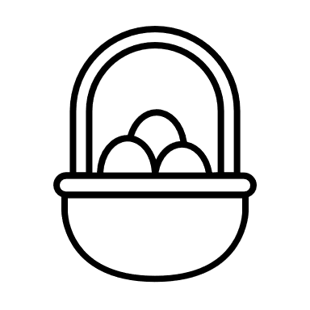
* No off-cycle payroll

