Instructions & Overview of Steps

The following information is intended to provide an overview of the performance planning, coaching and feedback check-ins, and evaluation process for the 2023-2024 classified staff performance management cycle.

Performance evaluations shall be used to coach Employees in their individual skill
development and career advancement opportunities

Step 1: Performance Planning
The basic premise in performance management is that an employee must know what is expected of them to be a highly effective performer. This is done by the supervisor and the employee collaborating to develop individual performance goals and objectives. To be most effective, individual performance plans directly stem from the position’s duties, team and Department’s goals and objectives. Ideal goals and objectives are considered to be SMART: Specific, Measurable, Attainable, Relevant, and Time-bound.

The process for the performance planning phase requires a meeting between the supervisor and the employee early in the performance cycle in which the following occur:

- The overall vision, values and goals of the Department are discussed.
- The individual and team goals, objectives and projects for the upcoming year are discussed.
- The Core Competency areas the employee will be evaluated on are reviewed.

Step 2: 90-day probationary period (if applicable)
Supervisors are required to conduct a performance discussion after completion of 90 days of the employee’s probationary period or trial service.

It is recommended that the supervisor review the expectations and competencies with the employee, inquire if they are acclimating to the position, if they have any questions or require any assistance or additional resources or training. Address areas of improvement or development as needed.

Step 3: Interim / Progress Review
CU requires a midyear progress review between employees and their supervisor. UCCS recommends two (2) mid-year progress reviews, but only one (1) is required. This meeting must be documented. Coaching and feedback are important objectives of this meeting. The midyear progress review meeting consists of:

1. A review and discussion of the work plan and any modifications resulting from changed business conditions since the plan was initially developed.
2. A preliminary rating and discussion of the employee’s performance on the goals and competency areas for the first six months.
3. Agreement on goals and competencies for the remainder of the year.
4. Written comments documenting progress and possible areas for improvement.
5. A review of progress toward training requirements.

Step 4: Final Written Evaluation
The end-of-cycle performance review involves a mandatory meeting between each employee and their supervisor. This meeting consists of a review and discussion of:
- all relevant performance data accumulated throughout the evaluation period
- employee’s performance on goals and competency areas
- completion of required and optional training

Process Overview:

** If employee within probationary period, be sure to complete 90- day check-in discussion regarding Job Performance

Timeline Overview:

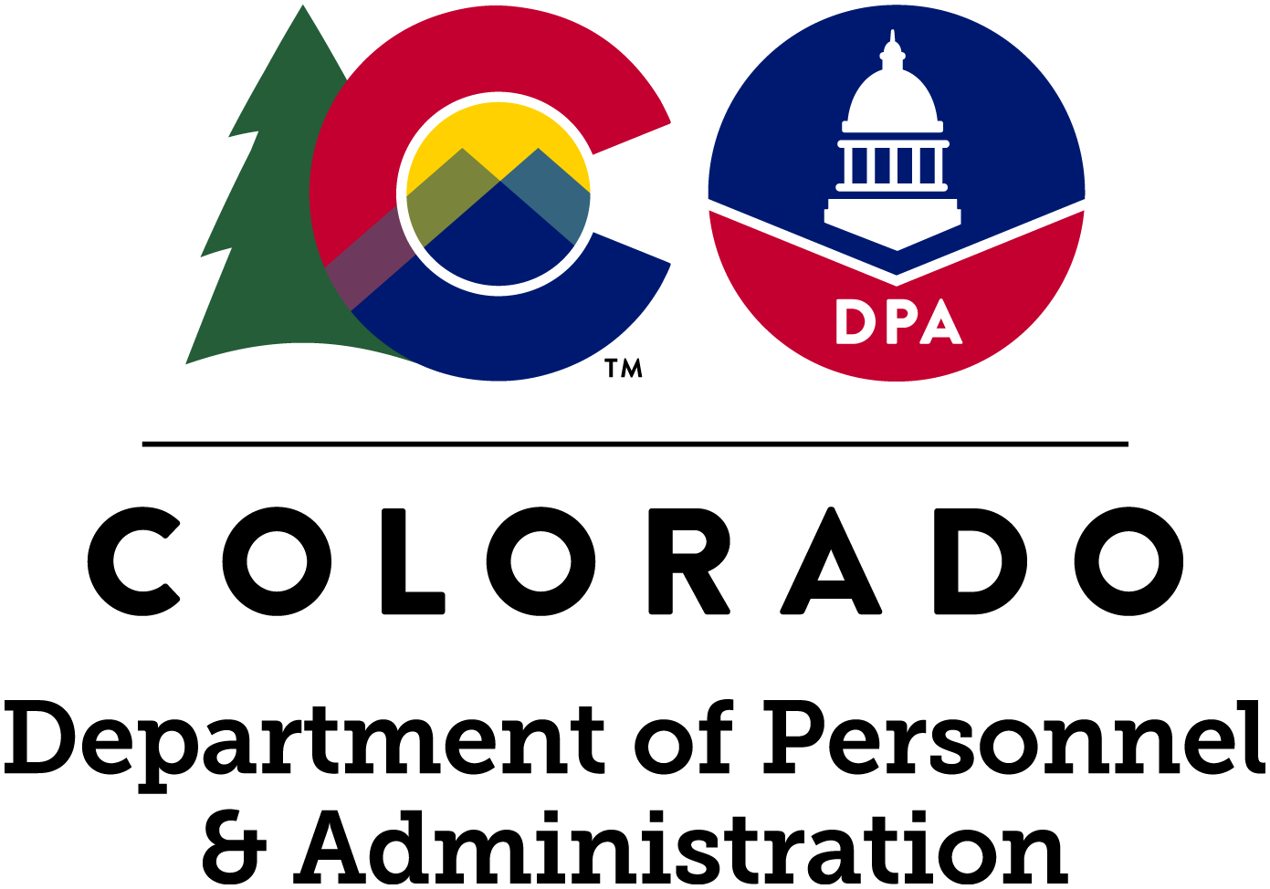
Performance Management Standardization

Descriptions of
5-Point Rating Scale

Level 5: Exceptional Employees at this level consistently make extraordinary contributions through superior performance on key goals, serve as a role model of organizational values, and contribute significantly to the mission of the Department. Peers, immediate supervisors, higher-level management, and others recognize and depend upon the employee’s level of performance. An extraordinary level of achievement and commitment in terms of quality and time, technical skills and knowledge, ingenuity, creativity, and initiative is exhibited at this level. The employee demonstrates exceptional job mastery in all major areas of responsibility and their contributions to the organization are of marked excellence.

Level 4: Highly Effective Employees at this level demonstrate highly effective performance by making significant contributions and impact on the goals of the Department. The employee consistently models organizational values to others and performance at this level exceeds the expectations of their position. Colleagues rely on these employees for advice on process or subject matter expertise. All goals, objectives, and targets are consistently achieved above the established standards.

Level 3: Effective Employees at this level reliably and consistently meet all the expectations, standards, requirements, and objectives of the employee’s position. They demonstrate organizational values, along with a willingness and ability to grow for the benefit of the Department. At this level, performance meets expectations in terms of quality of work, efficiency, and timeliness with the most critical goals being met.

Level 2: Needs Improvement At this level, employee performance and/or behavior do not consistently meet minimum expectations of what is expected of the employee’s position. While the employee shows capability and willingness to progress, they may require development in a key skill area(s) to be fully effective in the role. Employee’s failure to exhibit marked improvement may result in performance management.

Level 1: Unacceptable At this level, employee performance and/or behavior do not meet minimum job expectations of the position. The employee does not meet key goals and/or does not demonstrate competence in critical job skills. Immediate and sustained performance improvement is needed. Employee’s failure to exhibit immediate marked improvement will result in corrective and/or disciplinary action

University of Colorado at Colorado Springs Campus Mission Statement
The Colorado Springs campus of the University of Colorado shall be a comprehensive baccalaureate university with selective admission standards. The Colorado Springs campus shall offer liberal arts and sciences, business, engineering, health sciences, and teacher preparation undergraduate degree programs, and a selected number of masters and doctoral degree programs.
Vision Statement | UCCS, a premier comprehensive undergraduate and specialized graduate research university, provides students with academically rigorous and life-enriching experiences in a vibrant university community. We advance knowledge, integrate student learning with the spirit of discovery, and broaden access to higher education for the benefit of southern Colorado, the state, the nation, and the world.
Core Values | Integration  Innovation  Collaboration  Inclusive Diversity  Dynamic Responsible Growth  Integrity

DEPARTMENTAL VALUES (*Optional)
Your department’s values are the set of guiding principles and fundamental beliefs that employees follow as defined by the purpose of the department serving the citizens of Colorado.
Inclusivity | - Contributing to and maintaining a consciously unbiased environment where everyone feels welcomed, respected, and valued as individuals while building a Colorado for All.
Service | Teamwork | Integrity | Responsiveness | Transparency
- Being helpful, useful, timely, and efficient in our actions, results, and communication.
- Collaborating with and empowering each other to achieve success.
- Being honest and fair in our work and relationship.
- Engaging and following through in a way that promotes respect, energy, creativity, and adaptability.
- Operating with accountability, clarity, and ethics in a way that builds and sustains trust.

CORE COMPETENCIES - Mandatory
The Core Competency areas are defined by the State and have associated expectations and specific desired work behaviors. Additional goals or objectives that are competency specific can be added to an employee’s performance plan.
Performance Management | (FOR SUPERVISOR’S ONLY) Effectiveness in managing the performance of subordinate employees, including developing plans, conducting reviews and performance evaluations, coaching, providing feedback and resolving disputes.
Communication | Communication skills are very important and must be honed, particularly in  a job in which employees deal with customers (internally or externally). Clear communication requires straightforward language that is neither too flowery or too simple. It is essential to be able to use the spoken and/or written word to get your point across simply and clearly.
Customer Service | Commits to satisfying internal and external customers.
Accountability | Demonstrates a high level of dependability in all aspects of the job. Owns up to own words and actions. Can be relied on consistently.
Job Knowledge | Technically and professionally skilled in all position responsibilities and  duties. Seeks new skills and opportunities for self-development.
Interpersonal Skills | Interpersonal skills refer to the ability to interact positively and get  along well with others. It is defined as a set of positive social skills necessary to get along well with others and function constructively in groups, including:  A. Respecting and expressing appreciation for others  B. Being able to work and communicate well with others and listen to others' ideas  C. Demonstrating context-appropriate behavior that is consistent with social norms  D. Using a range of skills or processes aimed at resolving conflict
https://drive.google.com/file/d/1KX27sbfjOtNTYWkNdBPDNwFm936g5_3Y/view

